**Name-** Sushant Ashish

**ID-** 700747009

**Email-** [sxa70091@ucmo.edu](mailto:sxa70091@ucmo.edu)

**Github Link(Repo)-** <https://github.com/sushantUCM/ML-----Assignment5.git>

**Video Link -** <https://drive.google.com/file/d/1tnDna9-I-8em6dXfTsTLLNArzsNfIm27/view?usp=sharing>

**Part 4 explanation is given in this document as it is an observation**

My execution explanation is also given in comments

1. Principal Component Analysis

a. Apply PCA on CC dataset.

b. Apply k-means algorithm on the PCA result and report your observation if the silhouette score has improved or not?

c. Perform Scaling+PCA+K-Means and report performance.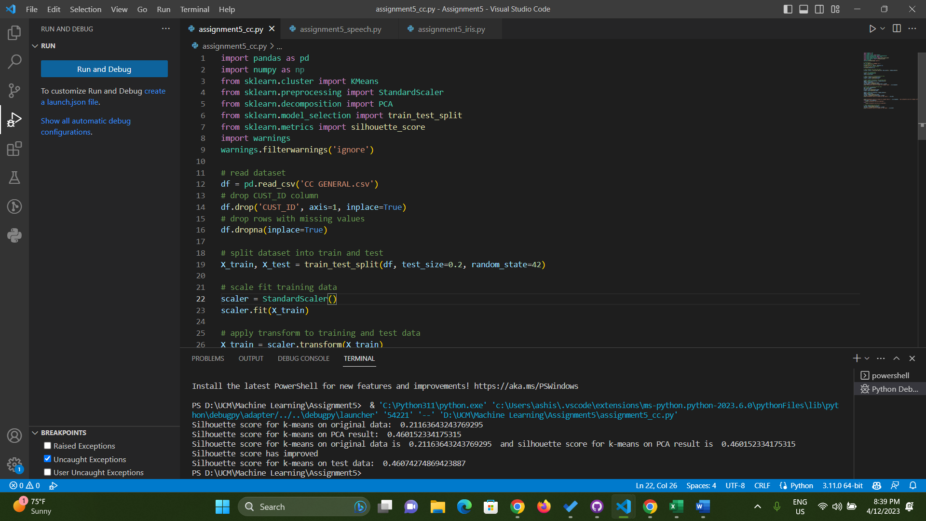Above screenshot shows the first part of assignment 5. I have split all 3 question parts in separate python files. Following the Reference Code provided, I have applied PCA on the CC dataset, transformed them and scaled them, then used K-means with 2 clusters and have reported the silhouette score before and after applying PCA

2. Use pd_speech_features.csv

a. Perform Scaling

b. Apply PCA (k=3)

c. Use SVM to report performance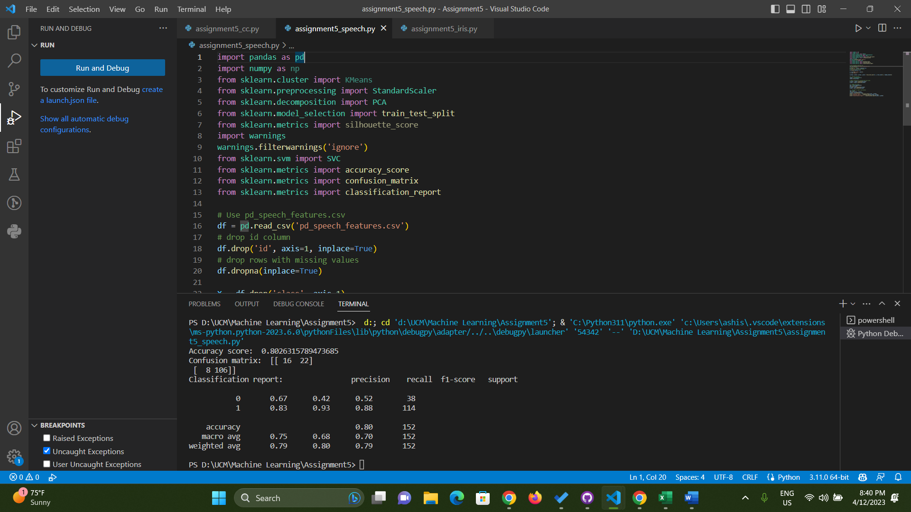

The above screenshot shows how I have used speech features dataset, scaled them, applied PCA.

After doing these steps I have used SVM classifier to get the accuracy score and classification report along with confusion matrix. It gave me an accuracy of ~80%

3. Apply Linear Discriminant Analysis (LDA) on Iris.csv dataset to reduce dimensionality of data tok=2.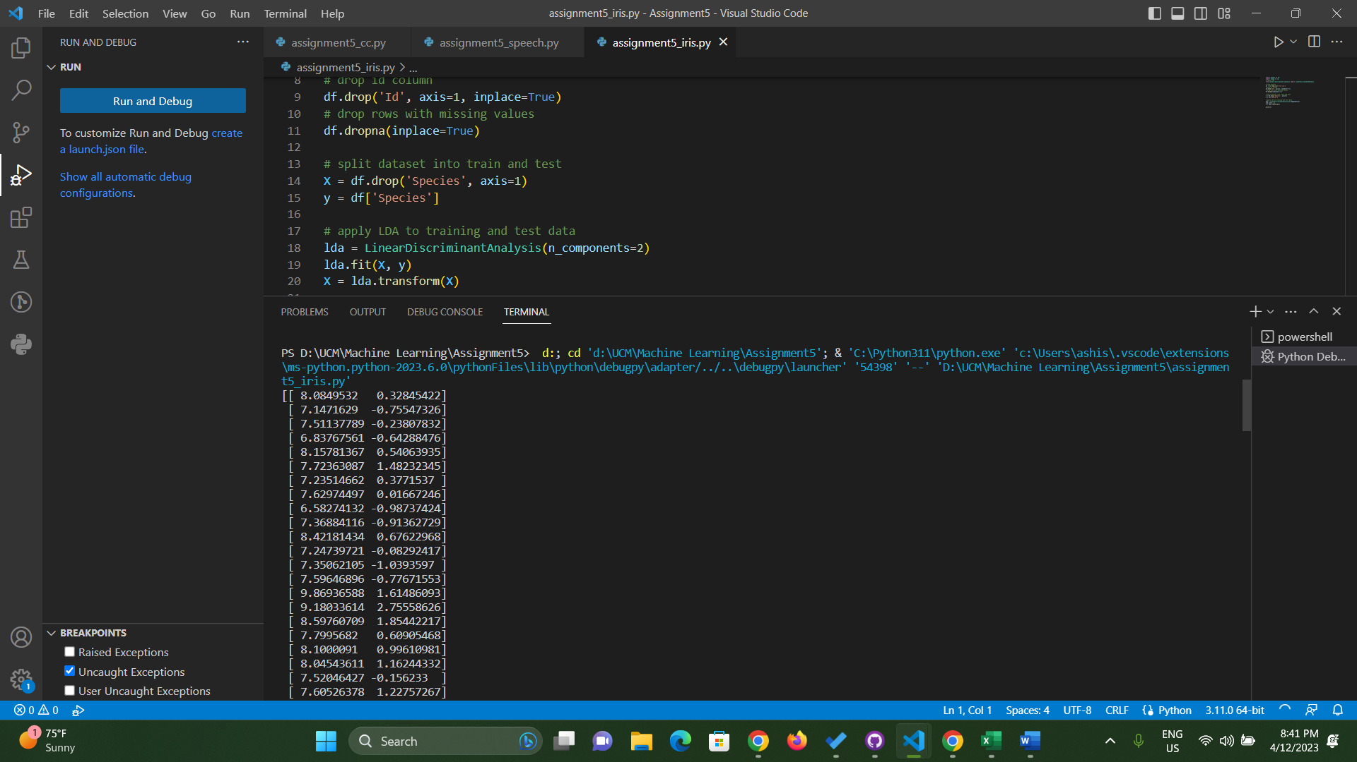

Above screenshot shows how LDA converts the Iris dataset to represent with 2 components by fitting class conditional densities to the data.

4. Briefly identify the difference between PCA and LDA

Answer - PCA is an unsupervised algorithm that is used to reduce the dimensionality of the data. It is used to find the principal components of the data. LDA is also a supervised algorithm that is used to reduce the dimensionality of the data. It is used to find the linear combination of features that characterizes or separates two or more classes.